Kenton County Airport Board
Airport/Airline/SAMS Safety Meeting Minutes
June 11, 2013
- Call to order
Brian Cobb called to order the regular meeting of the SAMS/Operations Meeting at 10:00 a.m. on June 11, 2013 in KCAB’s Board Room.
- Roll call
The following persons were present:
Not listed below: Chief Kevin Murphy, CBP Officer Steven Thompson
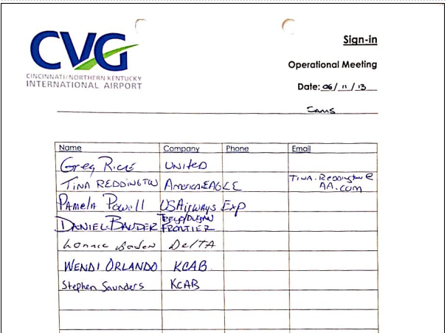
- Open issues from action item list
- NA
- New business
- 2nd month to discuss context of de facto safety committee; Kressler and Orlando briefed May meeting attendees; Cobb offsite for conference
- Cobb shared with those present that the group represents the customer base when discussing safety. Requested that the leaders share among their staff the joint responsibilities and this forum to share concerns.
- Opened floor to any present concerns; none voiced
- Cobb provided a rough timeline on skylight repairs in correlation to the rain mitigation efforts
- Adjournment
Cobb adjourned the safety portion of the meeting at 10:10 a.m.
Minutes submitted by: Brian Cobb
Minutes approved by:

