CVG Mass Notification System
The Kenton County Airport Board utilizes the Everbridge mass notification system to alert employees of irregular operations at the airport. This sheet will outline the basic information on how to register, receive messages, and confirm messages within the Everbridge app. The airport currently uses this system within the AOC, and we are currently in the process of expanding the capabilities.
To enhance our ability to notify you when required, please review the following information and complete the steps outlined below. Please direct any questions regarding the Everbridge app or SSO to the Airport Operations Center (859) 767-7777.
Step 1: Registration Email
You will receive a registration email from a KCAB representative requesting you to sign up for Everbridge. Please click the link and follow the prompts to sign up.

Step 2: Everbridge Application
The Everbridge app enables you to receive PUSH notifications on your smartphone/tablet device and provides a rich interface for interaction and detailed response.
When you receive your cellphone, the Everbridge app will already be installed on the device (if the app is not installed, contact KCAB IT). Once installed, open the app and use the User ID/Password combination you previously configured in the Everbridge Portal (above).
Upon successful login to the “app”, you may choose to Always Share your Location, Allow Push Notifications (enabled by default – this is the recommended setting), and set custom audible tones for Non-Priority and Priority Messages. Click DONE when you have finished setting your options.
The Everbridge app is now ready for use.
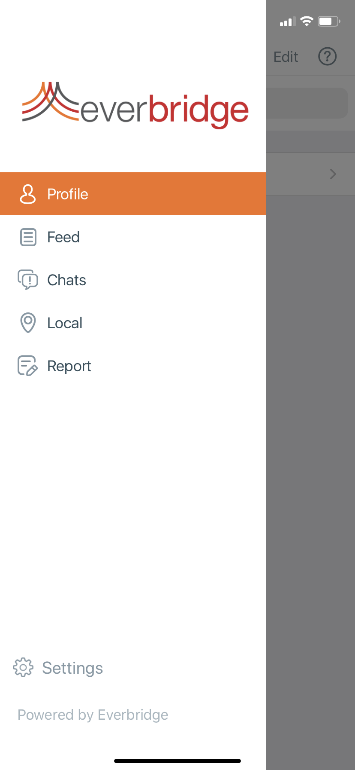
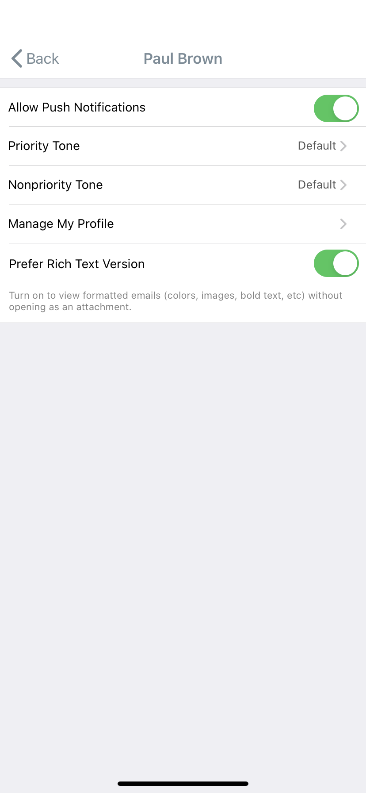

CVG – Everbridge
AWARENESS

CVG Mass Communication System

The Kenton County Airport Board utilizes the Everbridge mass notification system to alert employees of irregular operations at the airport. This sheet will outline the basic information on how to register, receive messages, and confirm messages within the Everbridge app. We will begin using the system on July 15, 2020.
During these notifications, you may receive a combination email, telephone, SMS text, and ContactBridge app PUSH messages. Each message will have an introduction, main content, and a confirmation component. The messages will be sent to the contacts and priority order you set up in step 2. If you do not respond to the notification on your first contact method, then the second contact method will be sent the notification, then sequentially from there on a timed interval ranging from zero to five minutes if you do not respond to the prompts given.
When received, please follow the instructions to confirm receipt of the message, choose a polling response, or join the conference call.

Email
- The emails will be sent from: CVG Airport Operations Center <noreply@everbridge.net>
- Review the entire message
- Click the link provided within the email to confirm receipt of the message
Telephone / Voice
- The telephone calls will be sent from: 859-767-7777
- The main content of the communications will follow
- To confirm receipt of the message, Press “1”

Everbridge app
- PUSH notifications will be sent from: CVG Airport
- Review the entire message
- To confirm receipt, tap Confirm in the Everbridge app when prompted
SMS / Text
- You will receive a text message on your smartphone or tablet device
- The message will arrive from short code 89361 or 87844
- Read the entire message then select reply from your device
- Reply with “Yes” and send to confirm receipt of the message

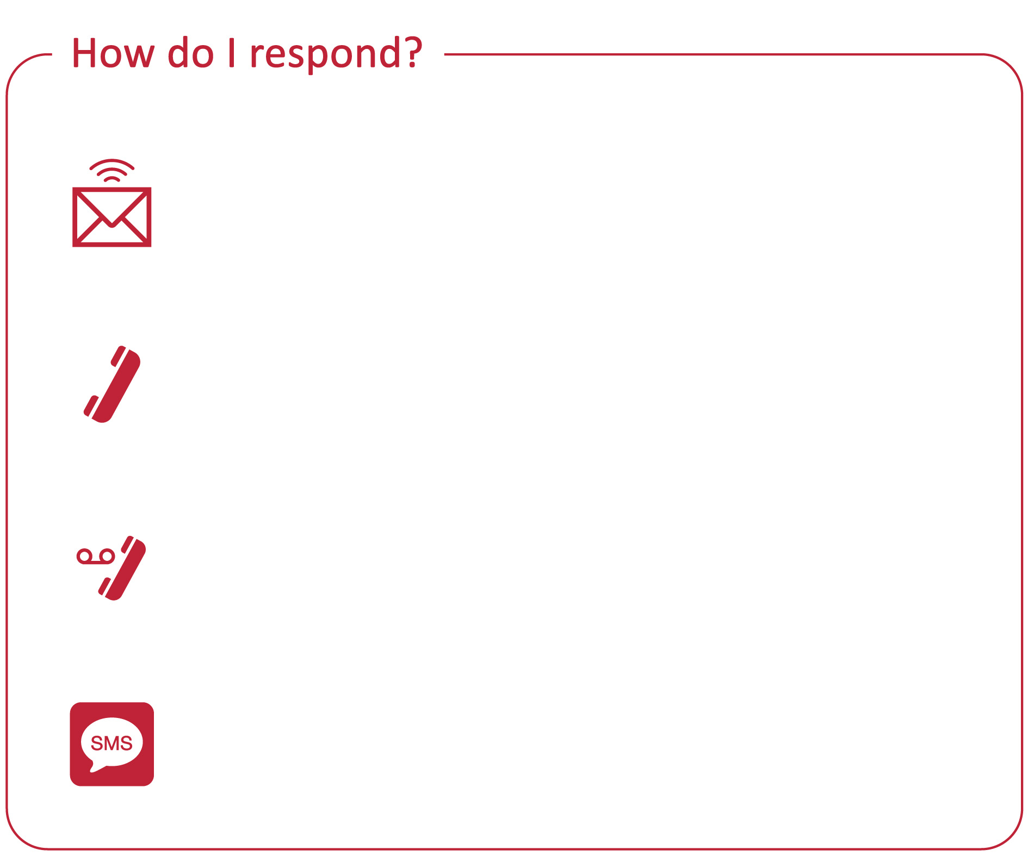
These communications are sent to help inform you of important conference details and critical communications in the event of an emergency.
Please contact the Airport Operations Center with any questions you may have.

